**Question 1**

#include <iostream>

using namespace std;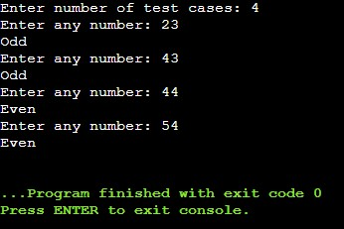

int main()

{

int t;

cout<<"Enter number of test cases: ";

cin>>t;

while(t--){

int n;

cout<<"Enter any number: ";

cin>>n;

if(n%2==0)

cout<<"Even"<<endl;

else

cout<<"Odd"<<endl;

}

return 0;

}

**Question 2**

#include <iostream>

using namespace std;

int main()

{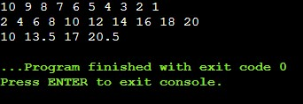

for(int i=10; i>0; i--)

cout<<i<<" ";

cout<<"\n";

for(int i=1; i<=10; i++)

cout<<2*i<<" ";

cout<<"\n";

for(int i=0; i<4; i++){

float a = 10;

a = a + i * 3.5;

cout<<a<<" ";

}

return 0;

}

**Question 3**

#include <iostream>

using namespace std;

int main()

{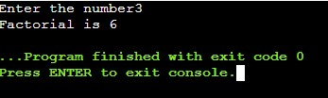

int n, fact=1;

cout<<"Enter the number";

cin>>n;

// for(int i=1; i<=n; i++)

// fact *= i;

int temp=n;

while(temp>0){

fact *= temp;

temp--;

}

cout<<"Factorial is "<<fact;

return 0;

}

**Question 4**

#include <iostream>

using namespace std;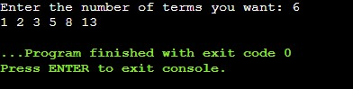

int main()

{

int n;

cout<<"Enter the number of terms you want: ";

cin>>n;

int a=0, b=1, c=0, count ;

// for(int i=1; i<=n; i++){

// cout<<c<<" ";

// a=b;

// b=c;

// c=a+b;

// }

// n = n-2;

while(n){

c = a+b;

cout<<c<<" ";

a = b;

b = c;

n = n - 1;

}

return 0;

}

**Question 5**

#include <iostream>

using namespace std;

int main()

{

int n;

cout<<"Enter size of array: "<<endl;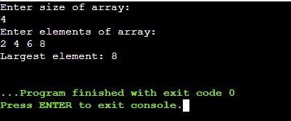

cin>>n;

int arr[n];

cout<<"Enter elements of array: "<<endl;

for(int i=0; i<n; i++)

cin>>arr[i];

for(int i=1; i<n; i++){

if(arr[0]<arr[i])

arr[0] = arr[i];

}

cout<<"Largest element: "<<arr[0]<<endl;

return 0;

}

**Question 6**

#include <iostream>

using namespace std;

int main()

{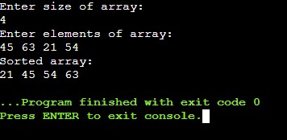

int n, temp;

cout<<"Enter size of array: "<<endl;

cin>>n;

int arr[n];

cout<<"Enter elements of array: "<<endl;

for(int i=0; i<n; i++)

cin>>arr[i];

for(int i=0; i<n; i++){

for(int j=0; j<(n-i-1); j++){

if(arr[j]>arr[j+1]){

temp = arr[j];

arr[j] = arr[j+1];

arr[j+1] = temp;

}

}

}

cout<<"Sorted array: "<<endl;

for(int i=0; i<n; i++)

cout<<arr[i]<<" ";

return 0;

}

**Question 7**

#include <iostream>

using namespace std;

int main()

{

int i, j, row, col, sum;

cout<<"Enter number of rows and columns: "<<endl;

cin>>row>>col;

int arr[row][col];

cout<<"Enter the elements: "<<endl;

for(i=0; i<row; i++)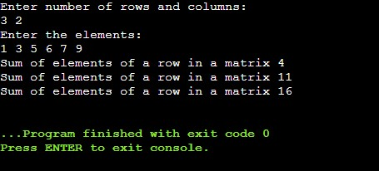

for(j=0; j<col; j++)

cin>>arr[i][j];

for(i=0; i<row; i++){

sum=0;

for(j=0; j<col; j++){

sum = sum+arr[i][j];

}

cout<<"Sum of elements of a row in a matrix "<<sum<<endl;

}

return 0;

}

**Question 8**

#include <iostream>

using namespace std;

int main() {

int row, column, i, j;

cout << "Enter rows and columns of matrix: ";

cin >> row >> column;

int arr[row][column], transpose[row][column];

cout << "\nEnter elements of matrix: " << endl;

for (int i = 0; i < row; ++i) 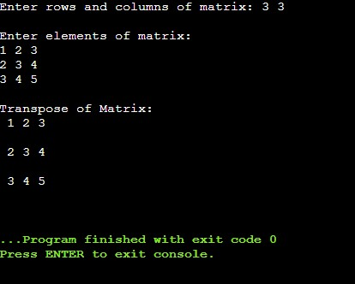

for (int j = 0; j < column; ++j)

cin >> arr[i][j];

for (int i = 0; i < row; ++i)

for (int j = 0; j < column; ++j) {

transpose[j][i] = arr[i][j];

}

cout << "\nTranspose of Matrix: " << endl;

for (int i = 0; i < column; ++i)

for (int j = 0; j < row; ++j) {

cout << " " << transpose[i][j];

if (j == row - 1)

cout << endl << endl;

}

return 0;

}

**Question 9**

#include <iostream>

using namespace std;

int main(){

string str;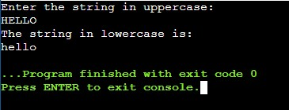

cout<<"Enter the string in uppercase: "<<endl;

cin>>str;

cout<<"The string in lowercase is: "<<endl;

for(int i=0; i<str.length(); i++){

str[i] = str[i] + 32;

cout<<str[i];

}

return 0;

}

**Question 10**

#include <iostream>

using namespace std;

int main(){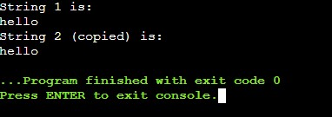

string s1, s2;

cout<<"String 1 is: "<<endl;

cin>>s1;

cout<<"String 2 (copied) is: "<<endl;

for(int i=0; s1[i]!='\0'; i++){

s2[i]=s1[i];

cout<<s2[i];

}

return 0;

}